**OUR TARGET AUDIENCE**



* Student
* Studies Geography
* Our game shall provide her an engaging and educational environment to learn about physical geography with her peers



* School Teacher
* Teaches Geography
* Our game shall provide her an interactive and educational method to teach her students physical geography



* Parent
* Wants his kid to learn more about the Earth
* Our game shall provide him and his kid a fun and educational way to learn about physical geography

AS-IS Situation Map

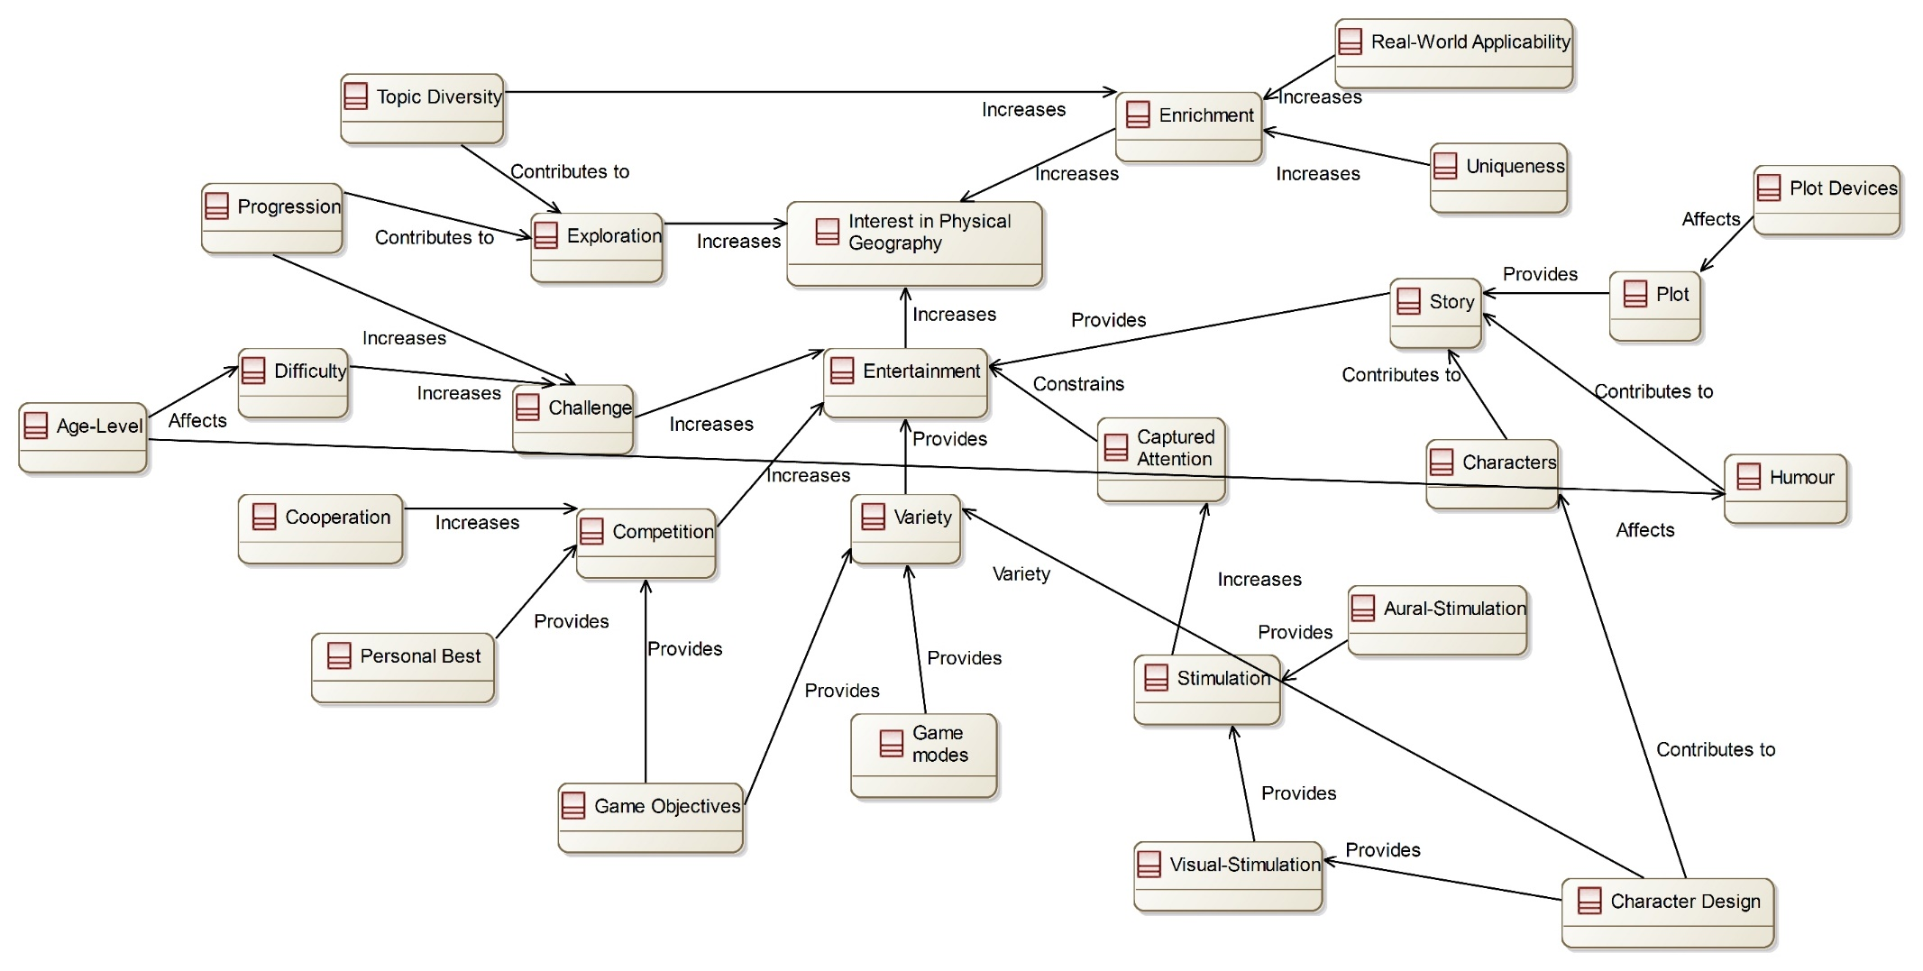

TO-BE Situation Map

